
January 2004
Summer/Fall
Vol. 15 No. 2

The North American Crane Working Group is pleased to announce the opening of its web site at www.nacwg.org

The webmaster is Richard Urbanek. Richard will be updating the site over the coming months. He can be reached at rurbanek@tds.net
You are also invited to visit the web site of the West Coast Crane Working Group at www.wccwg.nacwg.org

We want to acknowledge and thank The International Crane Foundation for hosting our web sites on their server and give special thanks to Dorn Moore for making it happen.

Thomas J Hoffmann, Treasurer
North American Crane Working Group
thoffmann@hoffmanns.com
206-286-8607

- It’s Dues Time! Please send your completed membership form (see the last page of this newsletter) along with your payment to Thomas Hoffmann.

- The Mississippi Sandhill Crane NWR is featured in the “This Land” segment of the December 2003 issue of Natural History.

- Don’t miss “Cranes” by Jennifer Ackerman in the April 2004 issue of National Geographic! This issue also includes an illustrated map of bird migration routes (Eastern & Western hemispheres).

- Don’t miss the new PBS Nature episode featuring the trials and triumphs of the first class of whoopers in the Eastern Migratory Whooping Crane Reintroduction project!
REGIONAL REPORTS

Florida non-migratory Whooping Crane Reintroduction Project

As of 21 January 2004 we monitored 72 birds (more are alive but are not trackable). We identified 17 pairs. The 2 chicks that fledged this year remained with their parents. This winter (December 2003) we soft-released 8 chicks at the Pruitt Ranch in Lake County and will release another 8 chicks in February.

Since our last report, another whooping crane died of power line collision in Lake County, near the site of the last collision. We met with the owners of the power line (Progress Energy) and they placed visibility markers on those lines in the vicinity of the problem area. These mortalities are the first that we’ve documented involving a high-voltage transmission line - other collisions to date have been with smaller, local lines.

Our first fledged chick, “Lucky”, hatched in 2002 and became independent of his parents in January 2003. During the 2nd half of 2003 Lucky spent much of his time with last winter’s release bird that had broken its leg (and healed). Those 2 and the other release-birds from last winter spent most of their time within 5 miles of the release site.

In April we had trans-located a male (1999 hatch) to Lake County where he quickly paired up with a female (1996 hatch) and even did some nest-building during the 2003 breeding season. This pair remained together and has already been observed doing some nest building behavior very early for this season (Christmas Day 2003)!

Since our last update, perhaps the most note-worthy thing is the number of captures that were made. During that time our capture rate was higher than ever before, with a total of 21 birds caught. Most (12) were caught using clap-traps. During 3 clap-trap events, we caught 3 birds simultaneously. Two of these multiple-captures were the families that fledged chicks this year. This enabled us to get transmitters on the new chicks that will allow us to track them after their independence from their parents.

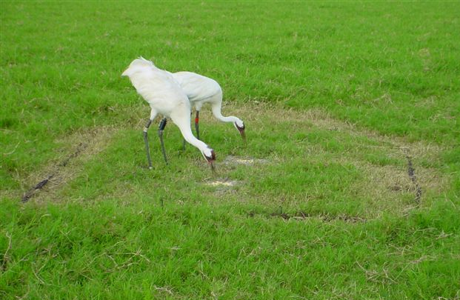

Fig.1. Pair 463/512 eats from a clap-trap set-up. 512 is the female that spent the summer of
2000 in Michigan (Florida marshes were completely dry that year). Photo by Steve Baynes.

Most captures were for the routine replacement of transmitters and for health checks. However, 2 individuals were trans-located to near other whooping cranes with the hopes of success like we saw with bird 926. Also, 3 birds with health issues were captured in order to examine/treat them. A 1994-hatch female had an injured left wing. We captured her and Dr. Marilyn Spalding treated the wing tip. The bird recovered and is flight-capable. Another bird, one that was released last winter, was captured when it was exhibiting secretive behavior and was drooping one wing. The bird did not require treatment and it recovered shortly thereafter. It is possible that these 2 birds tangled with barbed-wire fences. A third bird was captured in order to remove a rubber ring from its bill.

Blood samples taken at the time of capture allowed us to monitor a number of health parameters, perhaps the most important of which is Infectious Bursal Disease (IBD). High mortality of newly-released birds in winter 2001-2002 was associated with this disease. Virtually nothing is known about IBD in wild birds. Last fall, Marilyn Spalding reported: “Two batches of serum from Florida cranes, and three from International Crane Foundation, and one from Patuxent have been submitted to Dr. Holly Sellers at the University of Georgia for infectious bursal disease testing. Positive samples have been found at all locations, and include samples collected from the high mortality event in Florida cranes in 1998. The investigation is ongoing.” Marilyn’s findings suggest that some mortality in the past may have been associated with this disease. Bobcats may have been the “proximate” cause of death but IBD may have been the “ultimate” reason for their mortality.

Prior to quarantine in captivity, this winter’s cohort that was released in December showed evidence of exposure to IBD (high blood titers in half of the birds). However, by the time of shipment to Florida their titers had decreased to a level thought to be safe for shipment and subsequent soft-release. To learn more about IBD, this winter we are collecting blood from wild turkeys and from sentinel chickens caged near the release site. This spring we will also collect blood from sandhill crane chicks.

Marty Folk, Kissimmee, FL and Steve Nesbitt, Gainesville, FL

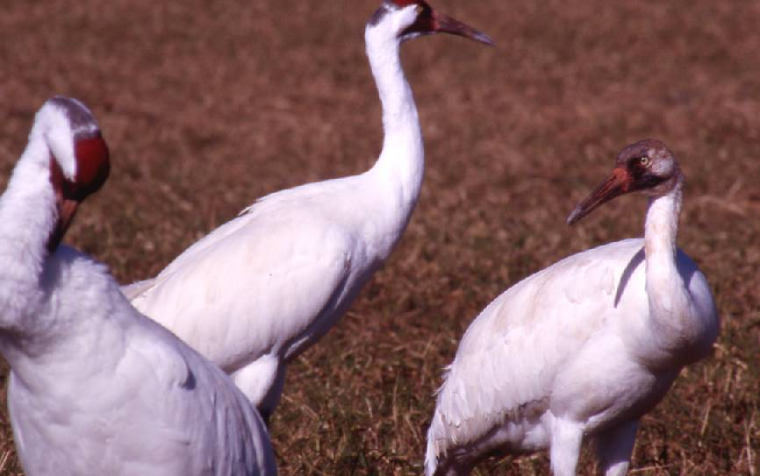

Fig. 2. Pair 591/369 and their fledged chick, photo taken 12 January 2004. At 10
months of age, from a distance the chick appears as an adult. The only brown
feathers left are scattered on the head and neck. Photo by Marty Folk.

********************************************************************************
GREAT LAKES

2002 Fall Sandhill Crane Census--Many thanks to Len Schumann (U.S. Fish and Wildlife Service, retired) for his many years as Fall Census Coordinator. Len attempted to continue the coordinated count, but due to lack of participation by some key cooperators, there was no completed count for 2002. Sean Kelly (U.S. Fish and Wildlife Service, Twin Cities, Minn.) will assume coordination duties for future counts. Jim Bergens reported 14,873 sandhill cranes at Jasper-Pulaski Fish and Wildlife Area (J-P), Indiana, on the coordinated count date, 30 October. Peak count at J-P was a record 34,629 on 26 November.

2003 Fall Sandhill Crane Census--The count at J-P on the coordinated count date, 31 October, was 15,262. Two peak counts, with smaller numbers in between, were 24,619 on 18 December and 21,735 on 25 November. Four of 20 whooping cranes in the reintroduced eastern migratory flock also passed through J-P during fall migration.

Richard P. Urbanek, Necedah, Wisconsin/Crystal River, Florida

********************************************************************************
Mississippi

During the 2003 nesting season, over 100 areas were searched with 22 nests recorded from 17 pairs. Three areas were used for the first time. The Wet Cell #2 CNA was used again for first time since 1991. Three chicks fledged and still survive.

A breeding male died from a power line collision. Three HY2001 cranes died, all of unknown cause. Twenty-nine people participated in the Autumn Crane Count observing 80 different cranes.

In the 24th year of restocking, three captive-reared cohorts totaling 14 birds were transferred from ACRES to the refuge in November and released in December. One group was placed in a new release site in the Firetower Pond. A third cohort with nine birds total from ACRES and White Oak was transferred to the Fontainebleau Pen in January.

The refuge Biological Review was postponed again until February 2004.

Scott Hereford, Gautier, MS

********************************************************************************

Wood Buffalo NATIONAL PARK Whooping Crane Update

Whooping Crane Breeding Grounds

At least 61 pairs nested during the 2003 breeding season. Habitat Conditions in the park and surrounding area were near normal at the time of nesting. At least 45 chicks successfully hatched and a minimum of 28 of those survived to fledging age. One pair was even able to raise 2 young to fledging age. The pair with the 2 young was the Lobstick pair that nests along Lobstick Creek just outside of Wood Buffalo National Park. The male of this pair is one of our oldest known birds at 25 years of age. He was originally banded as a chick back in 1978.

Whooping Cranes Summering Outside the Breeding Grounds

Two pairs and a single summered south of the breeding range. One of the pairs and a single were in south-central Saskatchewan, while the other pair spent the summer in British Columbia. This was the first confirmed sighting of whooping cranes in B.C. These B.C. cranes were first seen on the Fraser River near Prince George on June 30 and over the next 2 months moved east along the river to near McBride adjacent to Mount Robson Provincial Park.

Whooping Crane Fall Migration

Only 3 of the 25 family groups that arrived on the wintering grounds were sighted in Saskatchewan during fall migration. The pair with the 2 young arrived at their traditional fall staging area on Sept. 29 and remained there until October 17. On the morning of Oct. 17 they continued migration. The next time they were seen was 8 days later (October 25) and 3000 kilometres further south on their winter territory at Aransas. Sandhill Crane hunting was restricted at 5 locations in Saskatchewan due to the presence of Whooping Cranes.

Brian Johns, Canadian Wildlife Service, Saskatoon, Saskatchewan

~~~~~~~~~~~~~~~~~~~~~~~~~~~~~~~~~~~~~~~~~~~~~~~~~~~~~~~~~~~~~~~~~~~

Notes from the Field

UPDATE ON EASTERN MIGRATORY WHOOPING CRANE REINTRODUCTION

Spring Wandering Period 2003--Like the previous year, most of the whooping cranes moved about central and southern Wisconsin after completing spring migration and before settling on their summer home ranges. There were two main regions used during this period: the core reintroduction area in Central Wisconsin, and, secondarily, the area along the Lower Wisconsin River in southwestern Wisconsin.

Summer 2003--Of the 21 birds in the eastern migratory population, 20 were monitored. All of the 8 males summered in the core reintroduction area in Central Wisconsin. Of the 12 females, 5 that were associated with males summered in the core reintroduction area. Another summered in Central Wisconsin but north of the core reintroduction area, and the other 6 were widely distributed in Horicon NWR in southeastern Wisconsin (1), northwestern Illinois (1), southeastern Minnesota (1), and northeastern South Dakota (3). All whooping cranes that enter the Central Flyway are considered fully endangered, even those from the eastern migratory flock, which is classified as an experimental non-essential population in the states in and adjacent to the Wisconsin-to-Florida migration route. The presence of the latter birds in South Dakota therefore generated concerns that resulted in direction for their removal and transfer back to Wisconsin. Unfortunately, 1 bird developed capture myopathy and in a few days could not stand. After unsuccessful treatment efforts, she was euthanized. After release on Necedah NWR, the other 2 birds translocated from South Dakota moved to the Mississippi River in northeastern Iowa, where they remained until fall migration.

Fall Staging 2003--All 20 remaining birds were found. The 9 males and 7 of the females staged in the core reintroduction area in Central Wisconsin, the majority on Necedah NWR. The other 4 females staged at their late summer locations in Horicon NWR, northeastern Iowa, and northwestern Illinois.

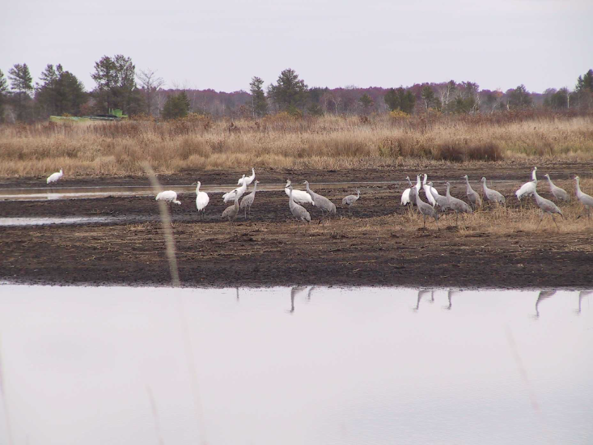

One- and two-year-old whooping cranes during fall staging at Necedah NWR, 2003.
Photo courtesy of Richard Urbanek.

Fall Migration 2003--Of 18 whooping cranes with fully functional transmitters, all migrated by an approximately direct route toward Chassahowitzka NWR on the Central Gulf of Florida, 7 November-2 December. Migration of individual birds or groups was completed in 5-23 days of which 4-8 were flight days. Fourteen of these birds arrived at the pen site in saltmarsh on Chassahowitzka, 16-29 November, before moving to inland winter locations. Peak count on Chassahowitzka was 12 birds on 30 November. The 2 whooping cranes with malfunctional transmitters were confirmed as far south as Hiwassee Wildlife Refuge, Tennessee, before apparently continuing migration farther south.

Winter 2003/04--The 18 trackable whooping cranes had settled on winter locations in the following counties of west-central and north Florida by mid-December: Pasco (9), Hernando (3), Sumter (2), Suwannee (2), Lake (1), and Madison (1). The latter 2 cranes were females within large flocks of wintering sandhill cranes. The former 16 birds were on ranchland and were not associated with large sandhill flocks. By early January, the 3 birds that had been in Hernando County had returned to the release site on Chassahowitzka NWR, and 1 of the 2 untrackable birds was found
wintering with sandhill cranes on Paynes Prairie, Alachua County.

Survival: With the exception of the translocation-related mortality, post-release survival of the 21 birds in the eastern migratory whooping crane flock was 100% from mid-January 2002 to mid-January 2004.

Richard P. Urbanek, U.S. Fish and Wildlife Service and International Crane Foundation, and Lara E. A. Fondow and Colleen D. Satyshur, International Crane Foundation, on behalf of Whooping Crane Eastern Partnership
PRESS RELEASE

WHOOPING CRANE POPULATION REACHES RECORD HIGH

The tallest bird in North America has something special to "whoop" about. The Aransas National Wildlife Refuge announced the highest numbers of endangered whooping cranes are wintering in Texas in approximately the last 100 years. U.S. Fish and Wildlife Service Whooping Crane Coordinator Tom Stehn completed a census flight on December 17th and tallied 194 whooping cranes. The current population exceeds by six the previous high of 188 whoopers present in the fall of 1999, and by 9 the peak population last winter.

The increase in numbers is due to very good nest production last summer. A record 61 nesting pairs fledged 27 chicks on their nesting grounds in Wood Buffalo National Park, Canada, as reported by the Canadian Wildlife Service. The young cranes were old enough to fly by mid-August increasing their ability to escape from predators and their survival. The record population of 194 includes 25 young cranes that have completed their first migration to Texas.

Although the whooping crane population remains endangered, the comeback of the species sets a standard for conservation efforts in North America. The population in Texas reached a low of only 15 birds in 1941, before efforts were taken to protect the species and its habitat. The population has been growing at 4 percent annually and reached 100 birds in 1987. "We were hoping for 200
whooping cranes in the year 2000, but the population went into a decline for a couple years before rebounding back to 185 cranes last winter, " said Mr. Stehn.

The whooping crane population continues to face many threats, including collisions with power lines in migration, limited genetic variability in the birds themselves, loss of crane migration habitat, and winter habitat threatened with loss of productivity due to reduced fresh water inflows and chemical spills.

The only natural wild population of whooping cranes nests in the Northwest Territories of Canada in summer and migrate 2,400 miles to winter at the Aransas and Matagorda Island National Wildlife Refuges and surrounding areas.

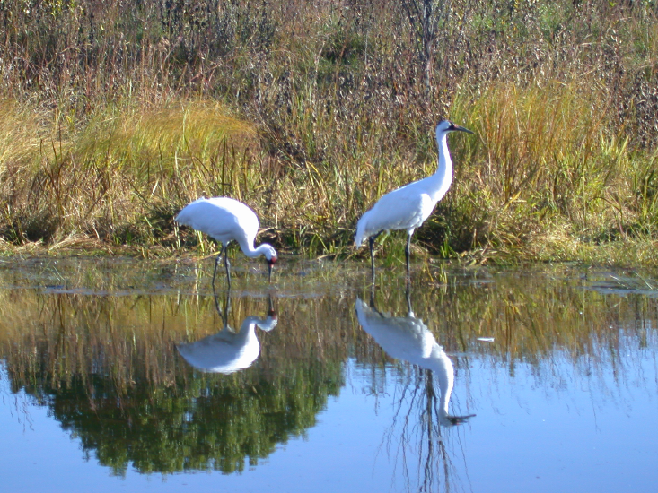
Photo by Joel Trick, USFWS
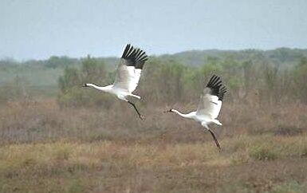
Photo by Steve Hillebrand, USFWS

The whooping crane migration starts in mid-September and is usually completed by mid-December. One adult female whooping crane was shot and killed during a closed waterfowl season on November 14th south of Dallas near Ennis, Texas. Charges have been filed in the case.

The whooping crane winter range stretches out over 35 miles of the Texas coast about 45 miles north of Corpus Christi, Texas. Wintering whooping cranes use salt marsh habitat foraging primarily for blue crabs. Unlike most other bird species, whooping cranes are territorial in both summer and winter and will defend and chase all other whooping cranes out of their estimated 350-acre territories.

A population census takes up to 8 hours of flying to cover the 55,600 acres of marsh over a 35-mile stretch of the Texas coast to find all the cranes. These flights determine the size of the total population, locate crane territories, and search for any mortalities that may occur. "Finding every whooping crane every week is quite a challenge. We have thousands of other white birds in the marsh including pelicans and egrets that makes aerial spotting of cranes more difficult. Also, the cranes can move during a census flight and either not be counted or else be counted twice." said Mr. Stehn.

If a disease outbreak should occur affecting the Texas flock, a contingency plan to reintroduce two additional flocks into the wild is in place. Since 1993, captive-bred whooping cranes have been released annually in central Florida. Today, that non-migratory flock numbers approximately 75 birds. During the past two years these cranes demonstrated their maturity by nesting and producing three chicks on their own.

A migratory flock was established starting in 2001 using an ultra light aircraft to teach the whooping cranes a migration route between Wisconsin and Florida. This migratory flock now numbers 36, with the cranes flying solo after being led on their initial trip across the eastern U.S. behind the ultralight. On December 8th, sixteen whooping crane juveniles completed their migration from Wisconsin led by ultra light aircraft. The team of pilots and biologists assigned this task make up the Whooping Crane Eastern Partnership. The current total North American population of wild and captive whooping cranes is 432. For recent updates on whooping crane recovery, go to www.whoopingcrane.com.

Tom Stehn and Vicki Fox, USFWS

Mission of the North American Crane Working Group:

NACWG is an organization of professional biologists, aviculturists, land managers, and other interested individuals dedicated to the conservation of cranes and their habitats in North America.

NACWG:

- Sponsors a North American Crane Workshop every 3-4 years
- Promulgates technical information including a published Proceedings of a North American Workshop and a semi-annual newsletter
- Addresses conservation issues affecting cranes and their habitats
- Promotes appropriate research on crane conservation and management
- Promotes a better understanding and appreciation of cranes and their habitats among the general public

Editor’s Note: The Unison Call is a forum to share updates and opinions. The articles in the “Notes from the Field” section are scientific updates and are not peer reviewed. Reviews and opinions included in any section of the newsletter are those of the author and do not represent the views of the NACWG.

The Unison Call is published twice a year, winter/spring and summer/fall. Membership is based on a calendar year. All contributions, suggestions, opinions, drawings, photos, and cartoons are very welcome! Please send newsletter items to:
SHERYL LEFFER
S70W19250 WENTLAND DR.
MUSKEGO, WI 53150
E-MAIL: sheryl@sigmaxi.org
Deadlines are July 20 and January 20. Please send information as an emailed Microsoft Word attachment whenever possible.

Please Join The North American Crane Working Group

Membership is based on a calendar year. A membership directory is periodically mailed to members. Check the information for contact information that you want printed in the directory.

_________Active $10 _________Sustaining $30 _________Contributing $50 _________Other $

_____Printed Copy of the Unison Call Additional $5, (all members with e-mail address receive electronic copy)

Name: ______________________________________________________________________________
Address: ______________________________________________________________________________
City:______________________________________________________________________________
State/Province: ______________________________________________________________________________
Zip/Postal Code: ______________________________________________________________________________
Email: _____________________________________@_______________________________________
Telephone: _________(______________)____________________-_________________________________
Mail completed forms and check (payable to NACWG) to:

NACWG
C/o Thomas J Hoffmann
341 West Olympic Place
Seattle, WA 98119

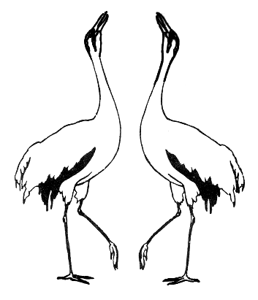

Return Address:
NORTH AMERICAN CRANE WORKING GROUP
341 West Olympic Place, Suite 300
Seattle, WA 98119

Board of Directors

President: Glenn Olsen
Vice-President: Gary Krapu
Secretary: Tracy Grazia
Treasurer: Tom Hoffmann
Felipe Chavez -Ramirez
Marilyn Spalding
Richard Urbanek

The Unison Call Published Semiannually by
Sheryl Leffer, Editor

